Title: **RSLogix Driver Setup** Handout: 2

Course: Introduction to Automation Unit: Introduction to PLC

**Objectives**

1. Student shall list, state, name, label, record, define, select, describe, reproduce (knowledge)
2. Student shall explain, translate, identify, describe, classify, locate, interpret, compare, estimate (comprehension)
3. Student shall apply, demonstrate, complete, sketch, construct, execute (application)
4. Student shall analyze, distinguish, differentiate, calculate, quantify, measure, relate, test, extrapolate (analysis)
5. Student shall develop, build, design, formulate, integrate, compose, collect (synthesis)
6. Student shall review, assess, appraise, select, measure, choose, evaluate, interpret (evaluation)

**Instructions**

Driver Setup - From your Window desktop type **Classic** in the *‘Search the web and Windows’* input in the lower left corner of your monitor.



Select the RSLinx Classic Desktop application.

RSWho - Select *Communications* then *RSWho*.

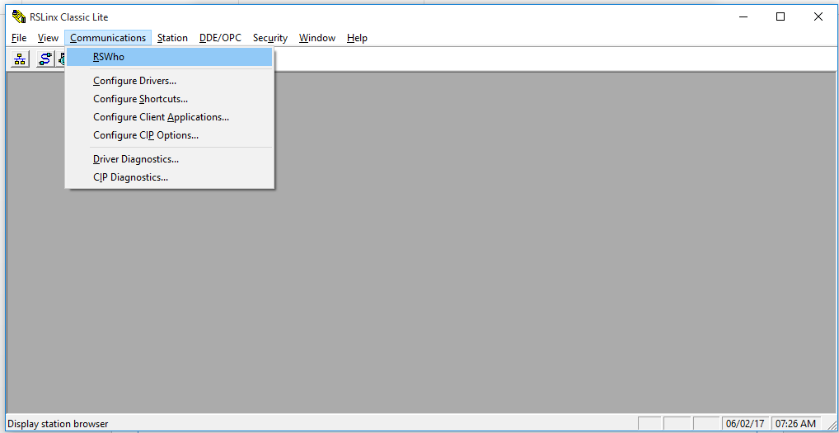

RSWho Results - Select the AB_ETHP_2, Ethernet card. This is the network interface card (NIC) on the side of your PC. A list of IP addresses will show that have red Xs over them. Those where previously connected devices that are currently unreachable. In the status bar a message should be displayed that states

***Browsing – node xxx.xxx.xxx.xxx found***

where the Xs will correspond to your PLC’s IP address. Communication is established. Nothing further needs to be done. You may close RSLinx Classic.

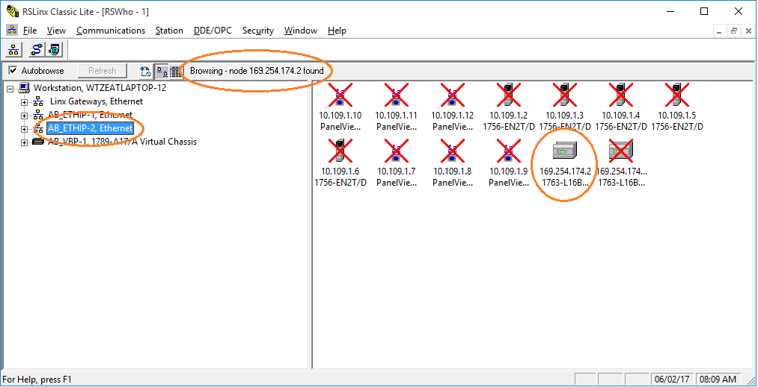

**RSLogix 500**

From your Window desktop type *RSLogix* in the *‘Search the web and Windows’* input in the lower left corner of your monitor.

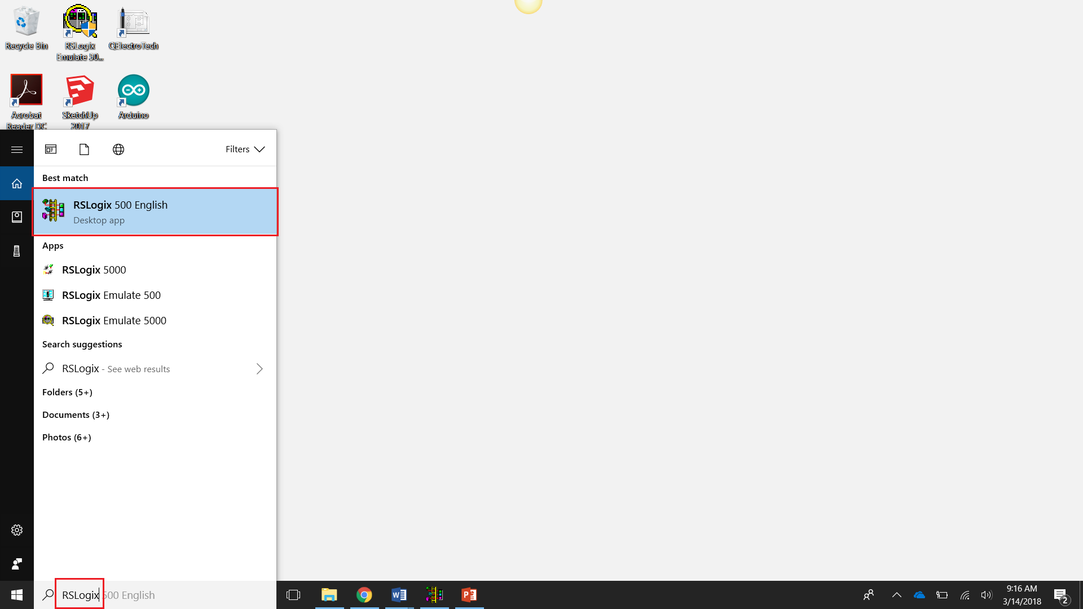

**RSLogix Who Active Go Online**

Select *Comms* then *Who Active Go Online*.

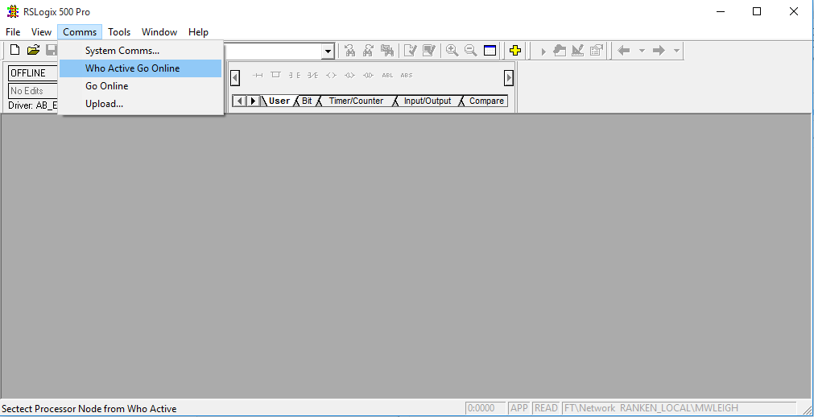

**RSLogix 500 Communications**

Below is the result of the Comms .> Who Active Go Online

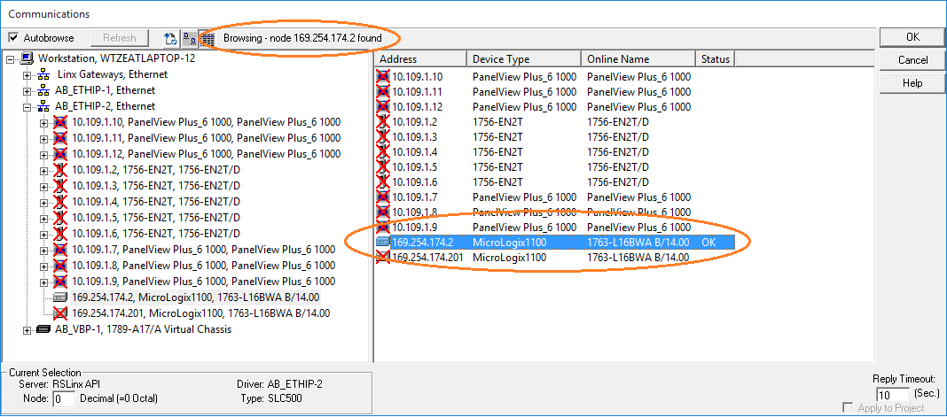

Look for your PLC’s address. It should not have a red X in its icon. Select the PLC’s address in the right window pane and press [OK].

**Going to Online Programming State**

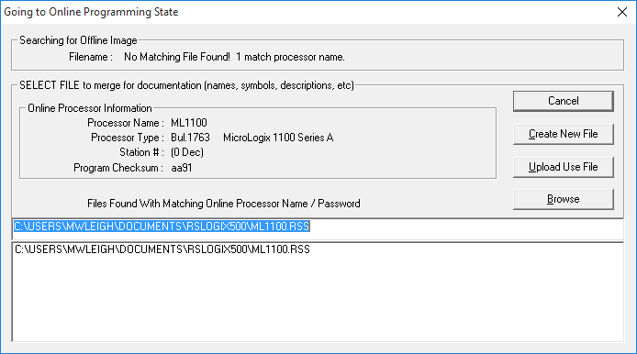

Select [Create New File].

**RSLogix 500 New Program**

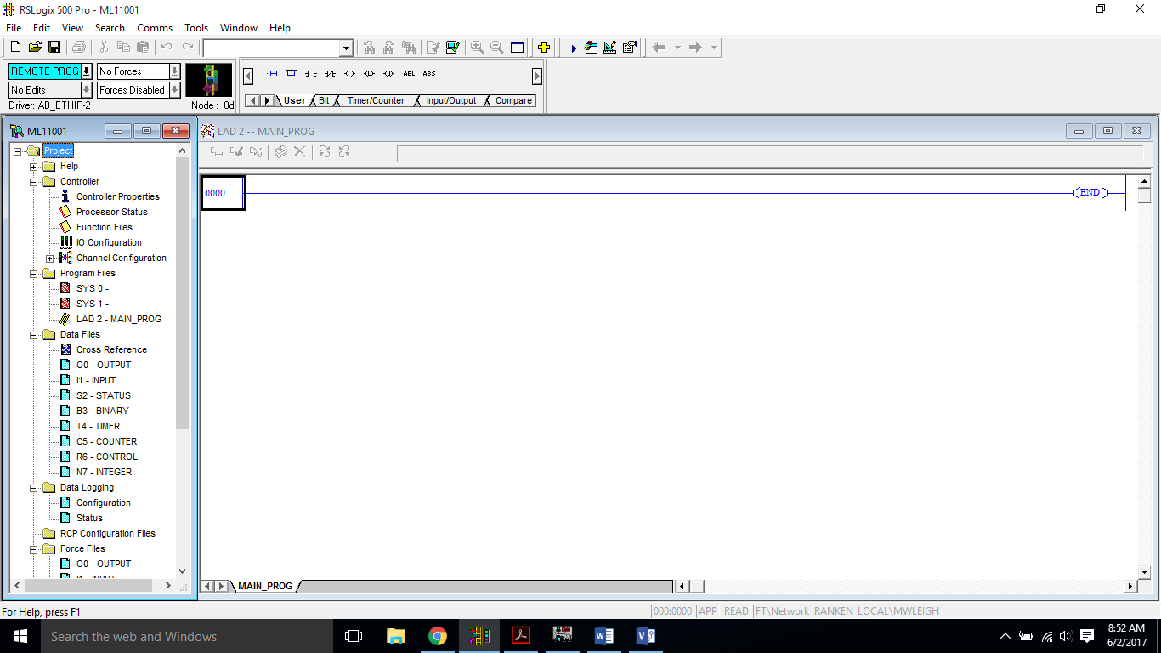

You may now begin programming.